Name: Huỳnh Phi Vân
ID: 2331200136

Q2: Postman Test

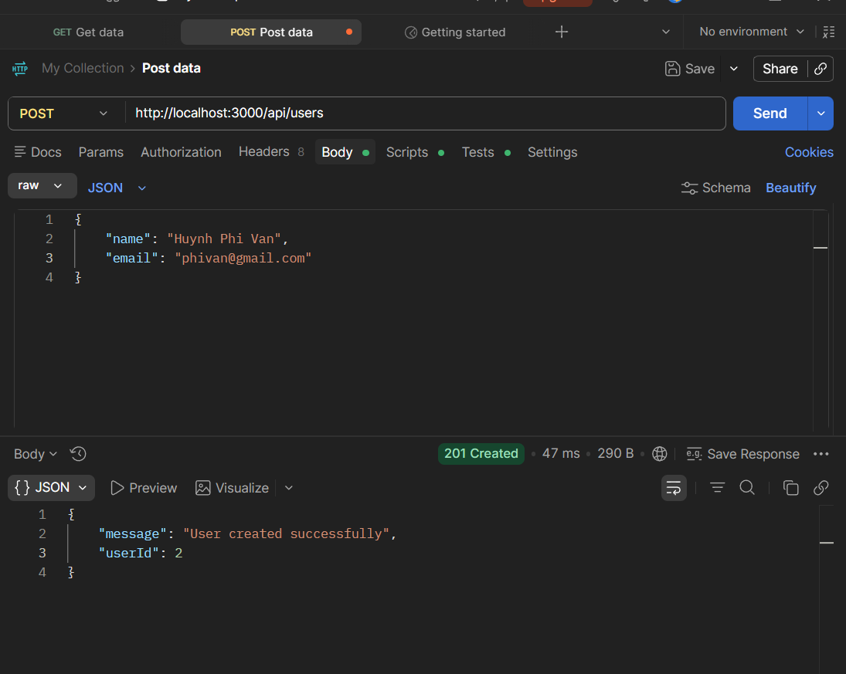
Huỳnh Phi Vân
2331200136

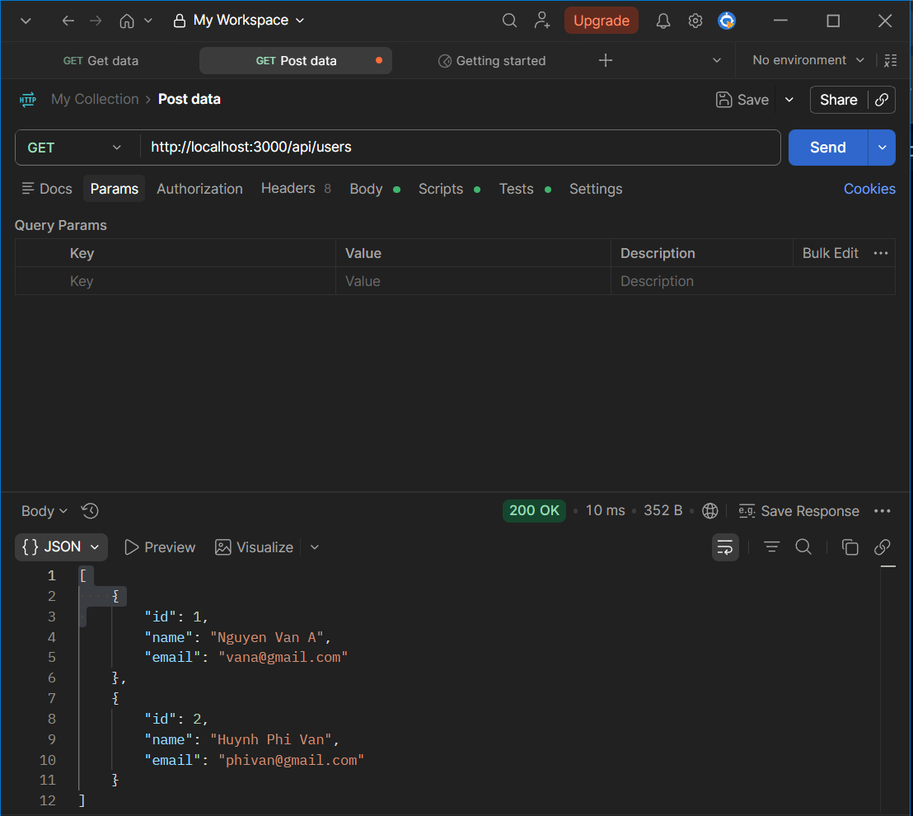
Huỳnh Phi Vân
2331200136

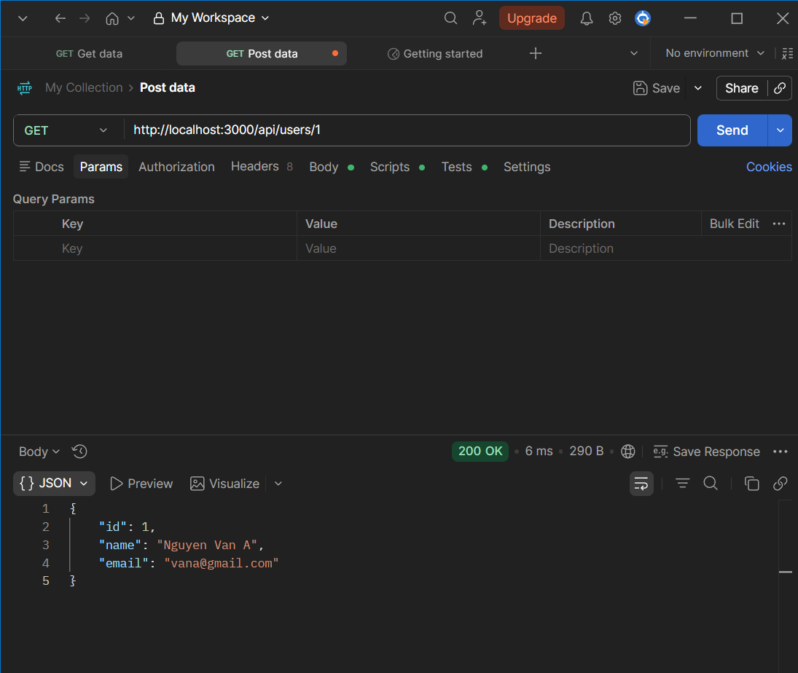
Huỳnh Phi Vân
2331200136

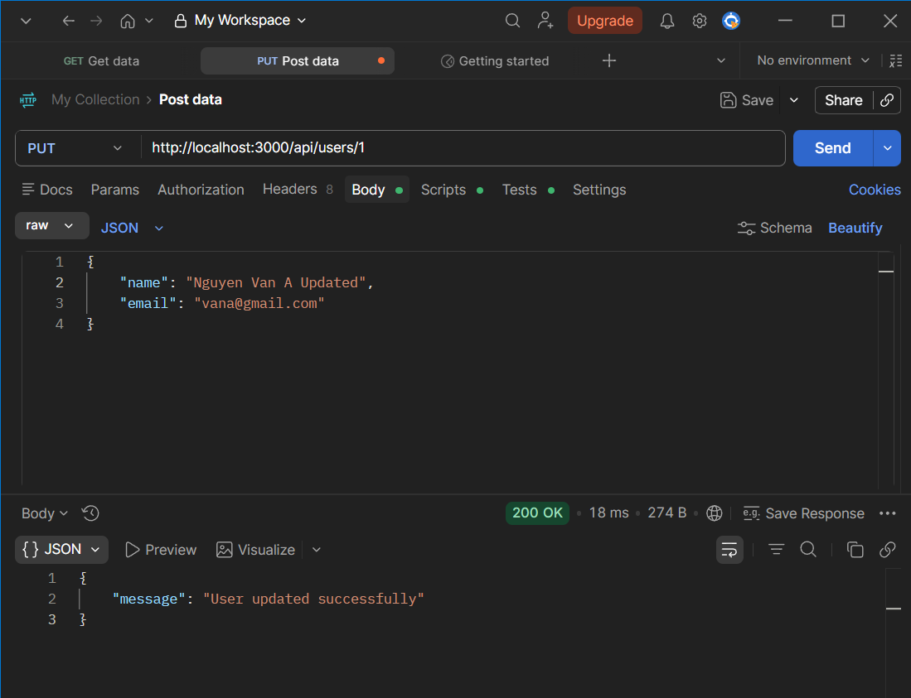
Huỳnh Phi Vân
2331200136

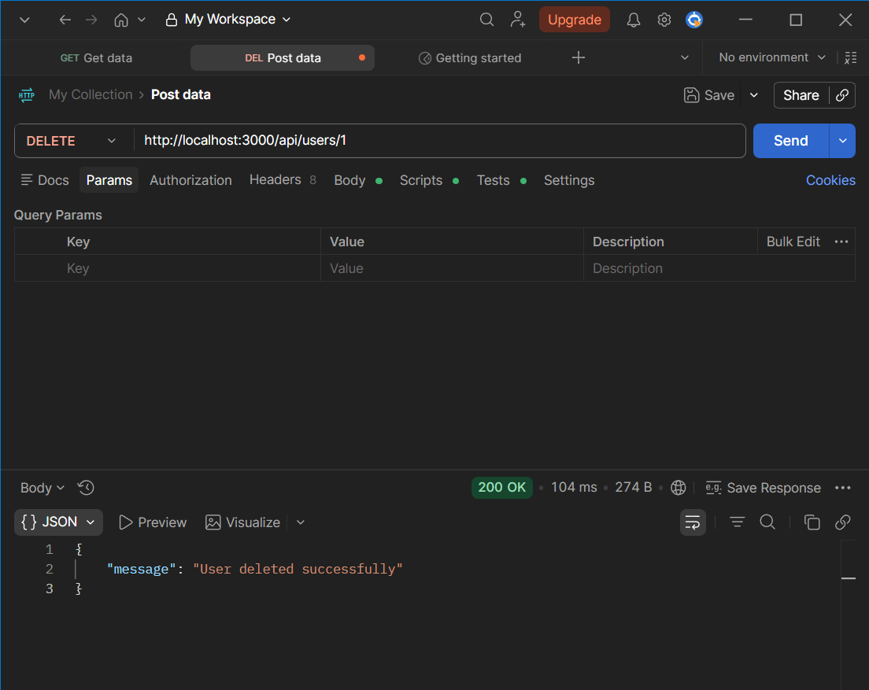
Huỳnh Phi Vân
2331200136
After DELETE, GET all users

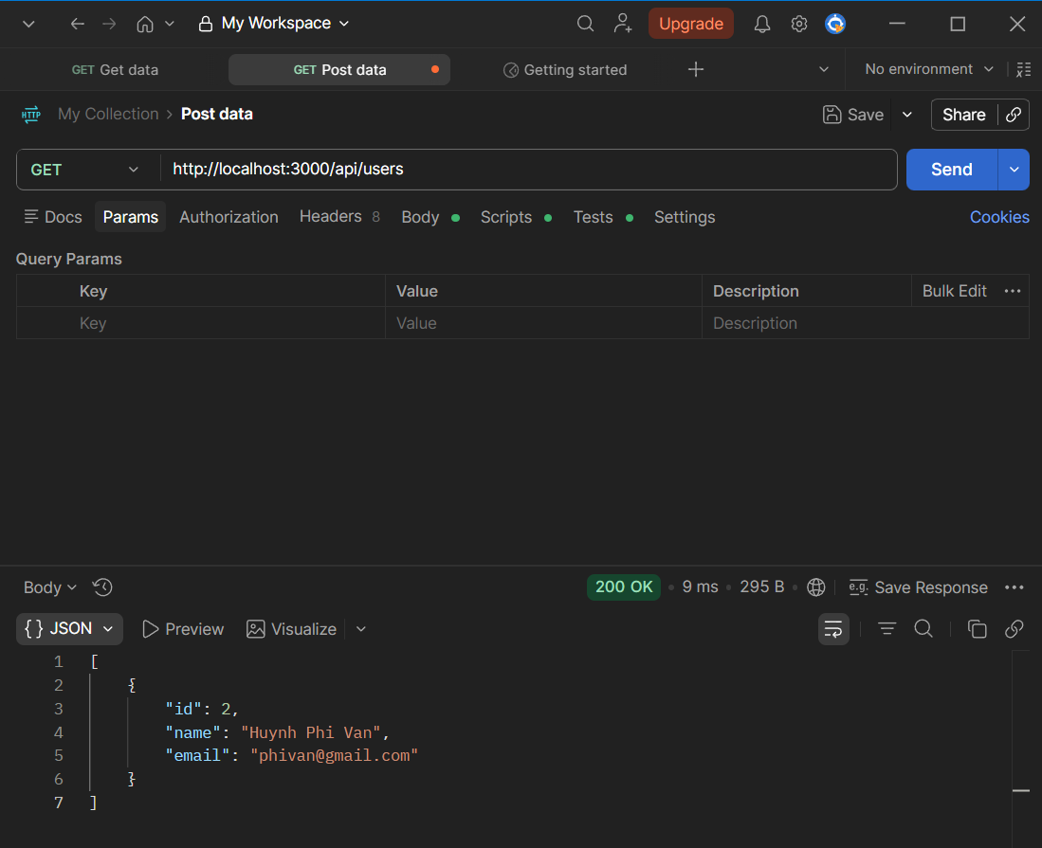
Huỳnh Phi Vân
2331200136

Q3 Login


Huỳnh Phi Vân
2331200136

Q4: Income Tax Calculator Q5: Calculator design interface

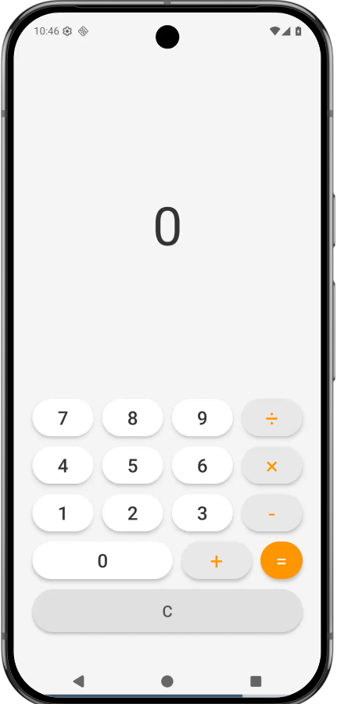
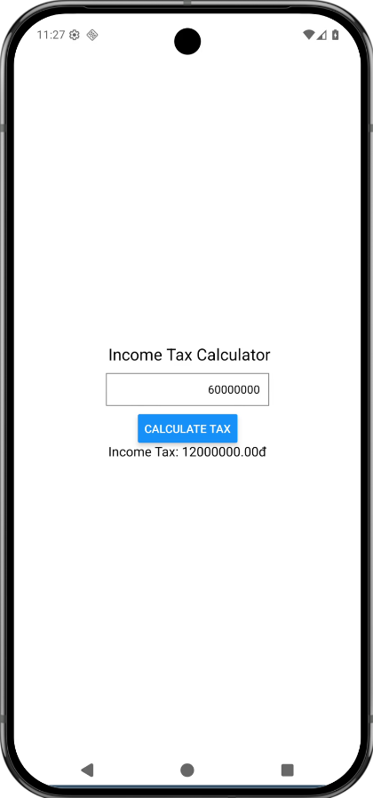

Huỳnh Phi Vân
2331200136
Huỳnh Phi Vân
2331200136

